Assignment sheet for IAM

Assignment 1 :- Create an IAM user with username of your own wish and grant

administrator policy.

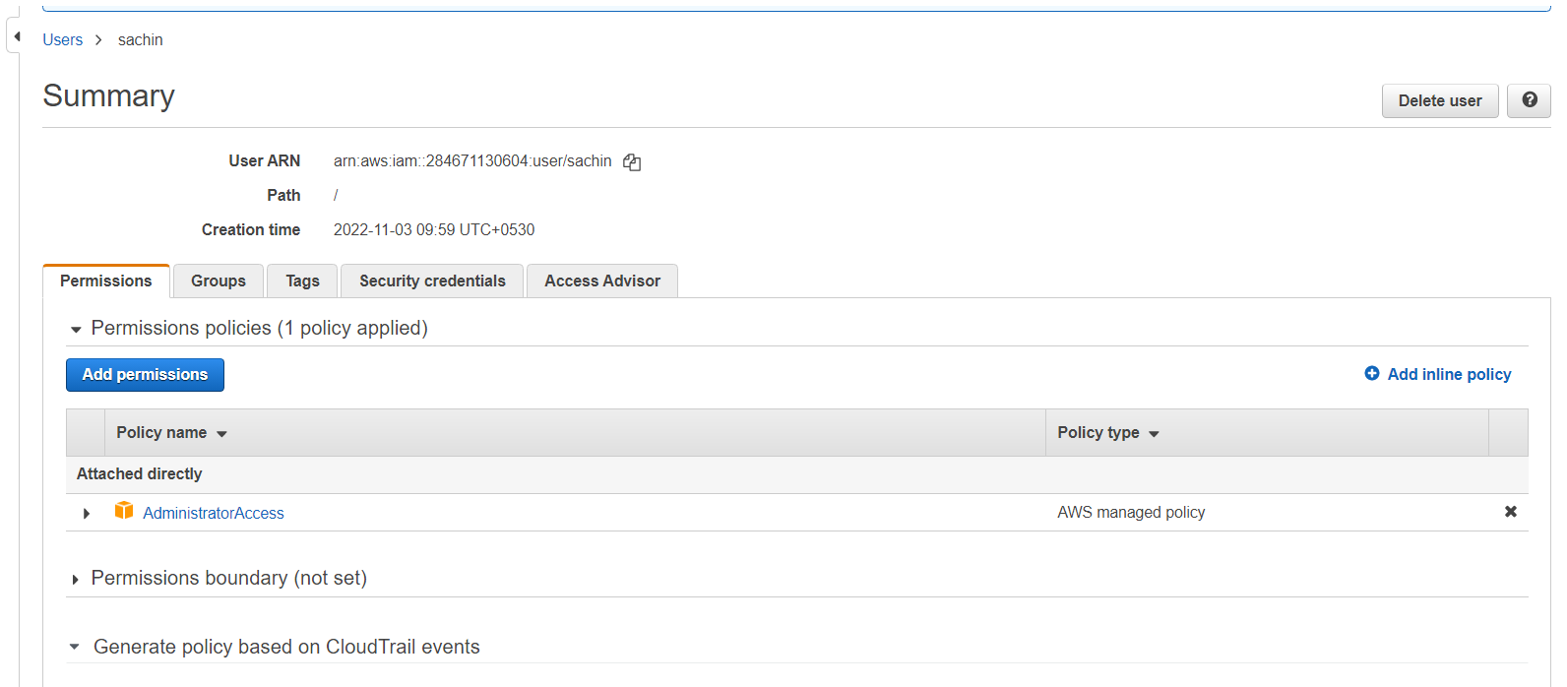

Assignment 2 :- Hello students, in this assignment you need to prepare a

developers team of avengers.

- Create 3 IAM users of avengers and assign them in developer’s groups with

IAM policy.

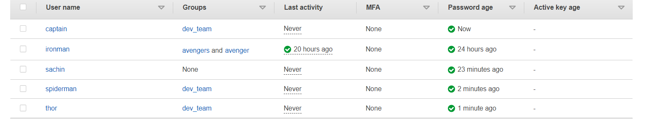

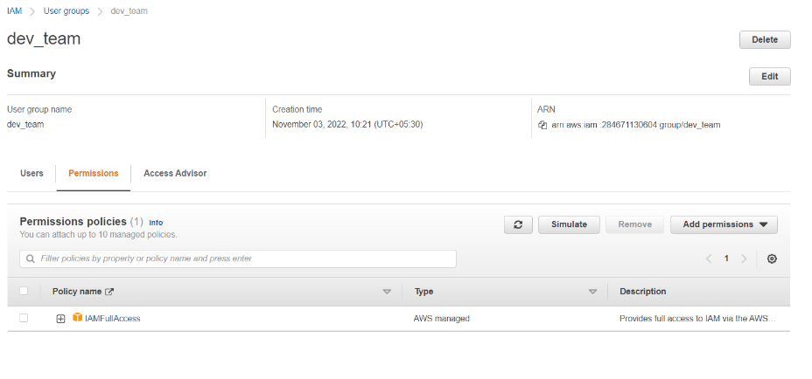

Assignment 3 :- Define a condition in policy for expiration like

**"DateGreaterThan": {"aws:CurrentTime":**

**"2020-04-01T00:00:00Z"},**

**"DateLessThan": {"aws:CurrentTime":**

**"2020-06-30T23:59:59Z"}**

Define the span of 4 months as per your wish

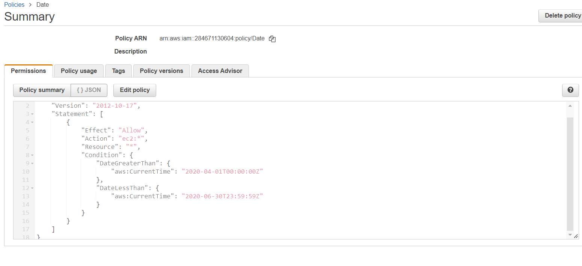

Assignment 4 :- Prepare 15 authentic MCQ questions related to IAM.

1. What’s AWS IAM?

The IAM’s full form is Identity and access management.

2. Are root users and IAM users the same?

No, the root user is also called the master user. The IAM user is subset of the root user.

3. In the IAM service, can we monitor the IAM user activity?

Yes, you can monitor the actives of IAM users. If any violation, you can remove access for the IAM user

4. How authentication is controlled in the IAM service?

You can mange the users. You can control access keys, passwords, multifactor authentication.

Manages federated users

5. What is federated user access management?

A user who is allowed to access AWS resources from third-party vendors – such as Google, Facebook, Linked In, Corporate credentials, etc.

6. What is Authorization in terms of AWS IAM service?

It’s to provide authorization for certain AWS resources – not all.

The best example is providing read-only access to the ‘S3’ service.

7. How to control Authorization in AWS IAM?

You can control authorization by creating policies.

8. How AWS IAM allows access?

AWS IAM Service These are Helpful Interviews Questions

9. What’s the other name of the IAM user?

You can also be called an IAM entity.

10. What is CloudTrail in AWS?

It’s a service, which records the logs of each IAM entity. So that you can use these logs for auditing and compliance purposes.

In these logs you will get answers for Who, When, Where, What, Which

Who made the request?

When was the request made?

What was the request about?

Which resources were acted upon in response to the request?

Where was the request made from and made to?

11. What are the 5 top security credentials in AWS IAM?

User-id and Password

E-mail address and Password

Access Keyes

Key pair

Multi-factor authentication

12. What are Temporary Security Credentials?

These are short-lived security credentials. These you can create from AWSSTS service (AWS security Token Service).

13. What are AWS IAM roles?

User – Specific IAM entity

Group – These people will have the same kind of Access

14. What are the top AWS IAM Roles?

In AWS IAM there are two types of roles. The IAM user will have a permanent identity. The federated user (Question# 5) will not have an identity.

15. What is the IAM Hierarchy of Privileges?

Root user

IAM user

user with temporary credentials

Assignment 5 :- Launch your linux instance in IAM and update your machine.

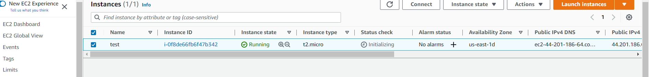

Ran sudo apt update and it updated the machine